**Steps to build and run the Java program on command prompt line**

1. java -version

Use this command on command prompt line to check whether java is installed. If Java is installed, we will see the following:

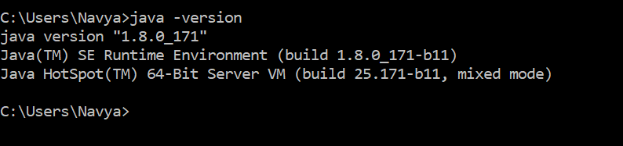

If Java is not installed, install latest Java version.

2. Set the class path and environment variables.

3. Write the program and save it using .java extension. To move to the folder where the java file is stored use cd command.

4. Let us start compiling the program using javac command.

javac Test.java

5. This invokes the Java compiler to compile code in the Test.java file into bytecode.

6. Once the code is successfully is compiled without any errors we can run our program.

A class with name Test (Test.class) is created which is bytecode form of Test.java.

If at all there are any errors in the code, the errors are displayed, and we can start resolving them.

7. So upon compiling the program we run the program using java command

java Test

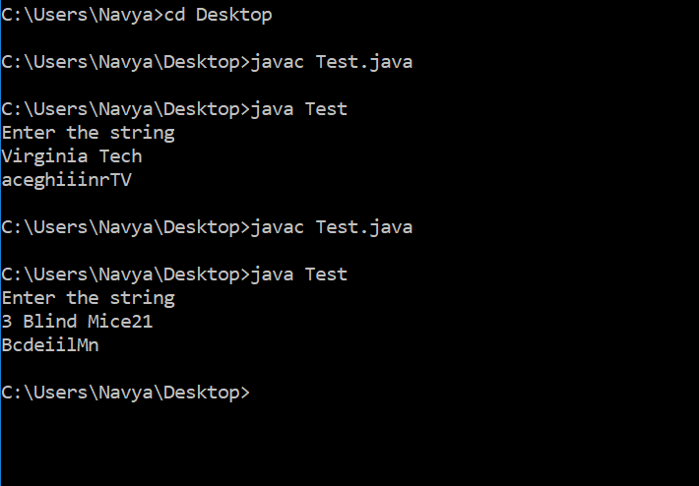

8. We can see the output after successfully running the program.